Portfolio Unit 12
Section 1: Vocabulary: Define each term
- Joint Frequency:

- Marginal Frequency:

- Relative Frequency (probability):

- Correlation Coefficient:

- Residuals:

- Interpolation:

- Extrapolation:

Section 2: Formulas/Equations/Rules (Show the process)

- To find the residual, _______________________________________________
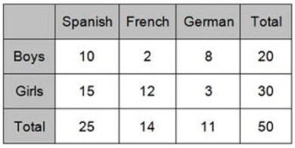
Section 3: Key methods and concepts
- Find the following based on the two-way frequency table below
- Number of students who are girls and speaks French._________
- Number of students who speaks German?______

- Total number of student’s surveyed.__________
- The probability of a student who is a female and speaks Spanish._____________

- The relative frequency of a student who is a male and speaks French________________
- The percentage of students who are boys____________
- The percentage of students who speak French____________
- The probability of a student speaking Spanish given that the student is a male__________
- The percentage of girls who speak German__________

- The percentage of students scoring 85 or better on a mathematics final exam and an English final exam during a recent school year for seven schools is shown in the table below.
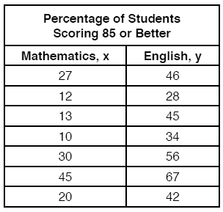
- Use the table above to make a scatter plot to represent these data.
- Write the linear regression equation for these data, rounding all values to the nearest hundredth.

- State the correlation coefficient of the linear regression equation, to the nearest hundredth. Explain the meaning of this value in the context of these data.

- Draw the line of best fit.
- Using the line of best fit, predict the percentage of students scoring an 85 or better in English if 55% of students scored 85 or better in math, rounded to the nearest integer.
- Use the line of best fit equation to find the predicted values to the nearest integer, and the residuals for each data point in the above table.
- Sketch a plot of the residuals below.
- Is the linear model the best model to represent this situation? Explain

